Project Design Phase-II
Data Flow Diagram & User Stories

Date | 08 July 2026
Team ID | SWTID-2026-1342
Project Name | Nutrition Assistant
Maximum Marks | 4 Marks

Data Flow Diagrams:
A Data Flow Diagram (DFD) is a traditional visual representation of the information flows within a system. A neat and clear DFD can depict the right amount of the system requirement graphically. It shows how data enters and leaves the system, what changes the information, and where data is stored.
Example: DFD Level 0 (Industry Standard)
Example: (Simplified)
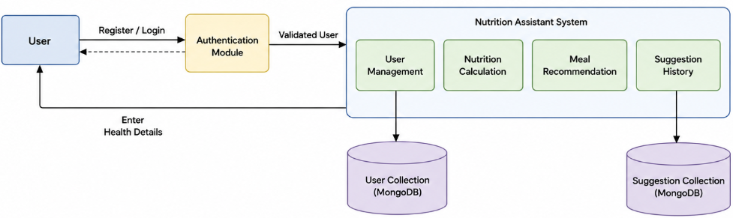
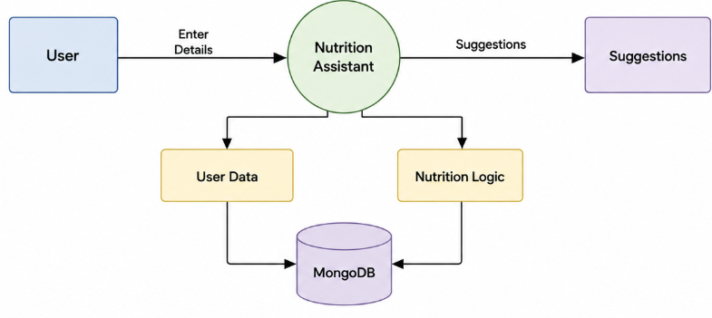

User Stories:
User Type | Functional Requirement (Epic) | User Story Number | User Story / Task | Acceptance criteria | Priority | Release
Visitor (Guest User) | Registration | USN-1 | As a visitor, I can create a new account using my personal details. | I can successfully create a new account. | High | Sprint-1
Registered User | Login | USN-2 | As a registered user, I can log in using my email and password. | I can login using valid credentials. | High | Sprint-1
Registered User | Profile Management | USN-3 | As a registered user, I can update my personal and health details. | I can save and update my profile details successfully. | High | Sprint-2
Health User | Nutrition Plan Generation | USN-4 | As a health user, I can generate a personalized nutrition plan. | I can generate a personalized nutrition plan with calories, protein, carbohydrates, fats, and meal suggestions. | High | Sprint-2
Health User | Meal Recommendations | USN-5 | As a health user, I can view meal recommendations based on my nutrition plan. | I can view recommended meals with calorie information. | Medium | Sprint-3
Registered User | Nutrition History | USN-6 | As a registered user, I can view my previous nutrition plans. | I can access and view my nutrition history. | Medium | Sprint-3
Registered User | Dashboard | USN-7 | As a registered user, I can view my dashboard with profile and nutrition summary. | I can view my dashboard with my latest nutrition summary. | Medium | Sprint-3
Administrator | User Management & Security | USN-8 | As an administrator, I can manage users and maintain application security. | I can manage users and monitor system security. | High | Sprint-4

